Project Design Phase Proposed Solution

Date | 02 November 2025
Team ID | NM2025TMID00163
Project Name | Laptop Request Catalog Item
Maximum Marks | 2 Marks

Proposed Solution Template:

S.No. | Parameter | Description
1. | Problem Statement (Problem to be solved) | In many organizations, the process of requesting laptops is manual, time-consuming, and prone to errors. Employees struggle with unclear request formats and delays in approval and fulfillment.
2. | Idea / Solution Description | The solution is to design a Service Catalog Item in ServiceNow named “Laptop Request.” It includes dynamic fields such as Laptop Model, Justification, and Additional Accessories. A Catalog UI Policy ensures that “Accessories Details” appear only when needed, and a UI Action (Reset Form) helps users clear the form easily.
3. | Novelty / Uniqueness | The project uses ServiceNow’s native catalog management tools to create a dynamic, user-friendly request form — without requiring any external integrations or coding plugins. It combines form automation, real-time validation, and deployment through update sets.
4. | Social Impact / Customer Satisfaction | It improves transparency and efficiency in IT asset management. Employees can easily request laptops, track their status, and avoid manual paperwork. This enhances user satisfaction and IT support response time.
5. | Business Model (Revenue Model) | While not directly revenue-generating, the solution reduces manual workload, minimizes delays, and streamlines hardware request operations — leading to time and cost savings for the organization.
6. | Scalability of the Solution | The solution can be expanded to include other hardware requests (like monitors or accessories) and automated approvals based on employee role or department. It is easily deployable across multiple ServiceNow instances.

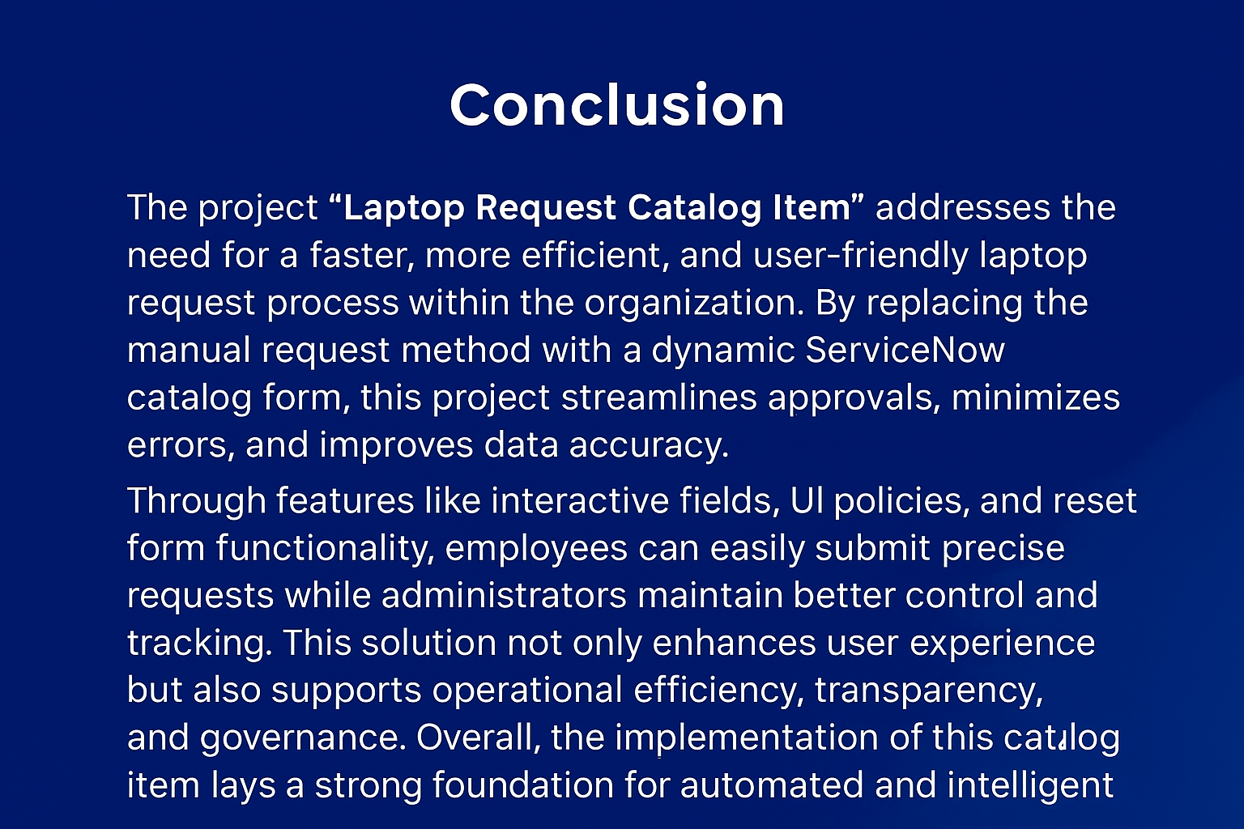

Solution Description:
The Laptop Request Catalog Item in ServiceNow provides a structured, automated approach for employees to request new laptops. It includes predefined fields for model selection, justification, and accessory details, ensuring accurate and complete submissions. Dynamic form behavior, implemented through Catalog UI Policies, enhances user interaction, while UI Actions like “Reset Form” simplify the process.
The project leverages ServiceNow’s built-in capabilities, ensuring seamless deployment through update sets and promoting maintainability, data accuracy, and improved workflow efficiency across the IT department.

